**Candy E-Commerce Sales Dashboard**

Objective: The owner of this store wants us to help them create a dashboard to track and analyze their online sales across India.

Step1: Create a Text Box to display the title of the dashboard.

Step2: Create a Stacked Column Chart to display the profit. For chart name: ‘Profit by Month’ - Use ‘Order Date-month’ of the X-axis (from the date hierarchy) and ‘Sum of Profit’ in the Y-Axis.

Step 3: Check the profit by sub-category. Create a stacked bar chart with name ‘Profit by sub-category’. Place ‘Sub-Category’ at Y-axis and ‘Sum of Profit’ at X-axis. This way the chat displays all the values, so we can consider the top 5 values.

Step 4: Check the product sales % as per Category. Let’s take a donut chart with ‘Category’ in the legend and ‘sum of quantity’ in the values.

For the label contents; go to format visual – Detail labels – Options – Label content- here select Category, % of total.

Step 5: Create another donut chart to check for the payment mode as per quantity. Use ‘payment mode’ at legend and ‘sum of quantity’ at values.

Step 6: Create a card visual representing the total amount of sales. Use ‘sum of amount’ in the fields section.

Step 7: Create a card visual representing the total quantity of sales. Use ‘sum of profit in the fields section.

Step 8: Create a card visual representing the total quantity of sales. Use ‘sum of quantity’ in the fields section.

Step 9: Create a card visual representing the average order value. To perform this task, go to the data view; select ‘details’ table, create a new column. Avg = [Amount] / [Quantity].

Step 10: Create a ‘stacked bar chart’ representing the top states from which the orders were placed. Drag state at the y-axis and ‘sum of amount’ at x-axis.

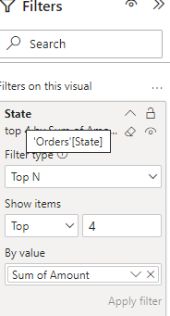

Step 11: Create another ‘stacked column chart’ displaying the customer who placed the highest orders. Drag ‘customer name’ at Y-axis and ‘sum of amount’ at x-axis.

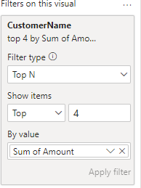

Step 12: Create a slicer to display quarter wise data with ‘quarter’ in the field.

Step 32: Create a slicer to display state wise data with ‘state’ in the field.

Outcome: For this particular use case, I've collected the data from the internet in the form of an excel sheet. I've done the required data cleaning and created multiple visualizations. With the help of these visualizations, the merchant can analyze the:

* total profit incurred.
* the top states from which the orders are being placed.
* Profit per month.
* Customers placing the highest number of orders.
* Profit as per the product category.
* Payment mode use for the orders.